# **Technical document**

1. **Project Overview**

* **App Name**: Fourity-Plants
* **Purpose**: An app for managing plant care duty in a workspace
* **Target Users**: Employees, Managers

1. **Entities and Data Models**

## 

## **Entity Name**: *Plant*

## **Attributes**: Id, Name, image_url, Sun Requirement, Water Requirement, ZoneId

## **Entity Name**: *Zone*

## **Attributes**: Id, Name, Employees

## **Entity Name**: *Plant record*

## **Attributes**: Id, EmployeeId, PlantId, IsWater, IsSun, Date, Status

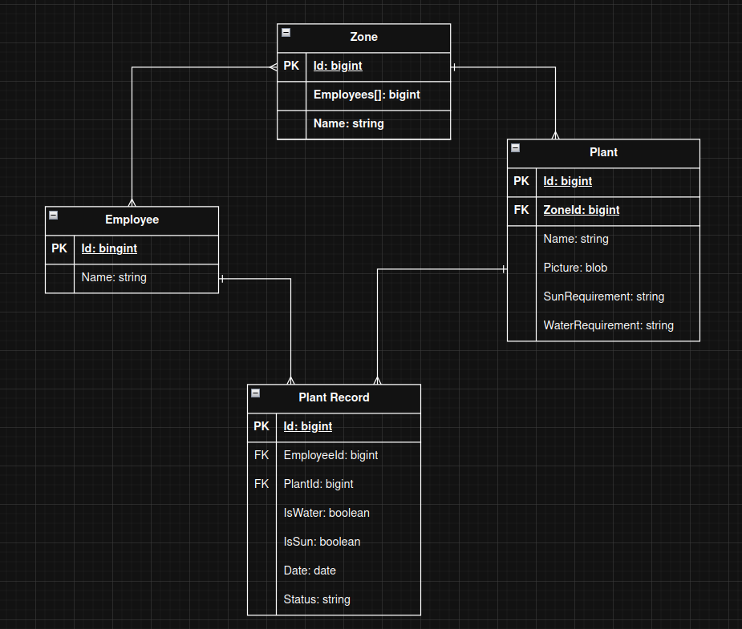

## [Link to drawio for ER diagram](https://drive.google.com/file/d/1uZSEPwpoDbEFuNxgwW6tQ5BPFjkIl3od/view?usp=drive_link)

1. **Features and Functionality**

* Employee management

Employees can be delegated to different zones

* Zone management

Zones can be created,and modified

* Plant management

Plants can be created, modified and delegated to different zones

* Duty Scheduling

App schedules duties for employees based on plant data & plant history and employee schedules

* Duty Delegating

Employees can delegate their tasks to others, as well as other employees can delegate themselves someone else's duty

* Scoreboard generation

App creates a scoreboard based on previous duty recordings

* Employee notification

App notifies employees of their duties

* Duty recording

App records when a duty is done for later scoreboards and scheduling

1. **Technical Questions and challenges**

* What database will be used?
* What technology will be used to create the application?
* What medium will be used for notifying employees?
* How will employees be added to the app?
* Do they need access to the frontend?